**FRAMBuilder 2.0**

**Program documentation & processing steps for preparing coded-wire tag data for Chinook FRAM base period calibration**

**The Chinook FRAM Base Period Workgroup, February 2016**

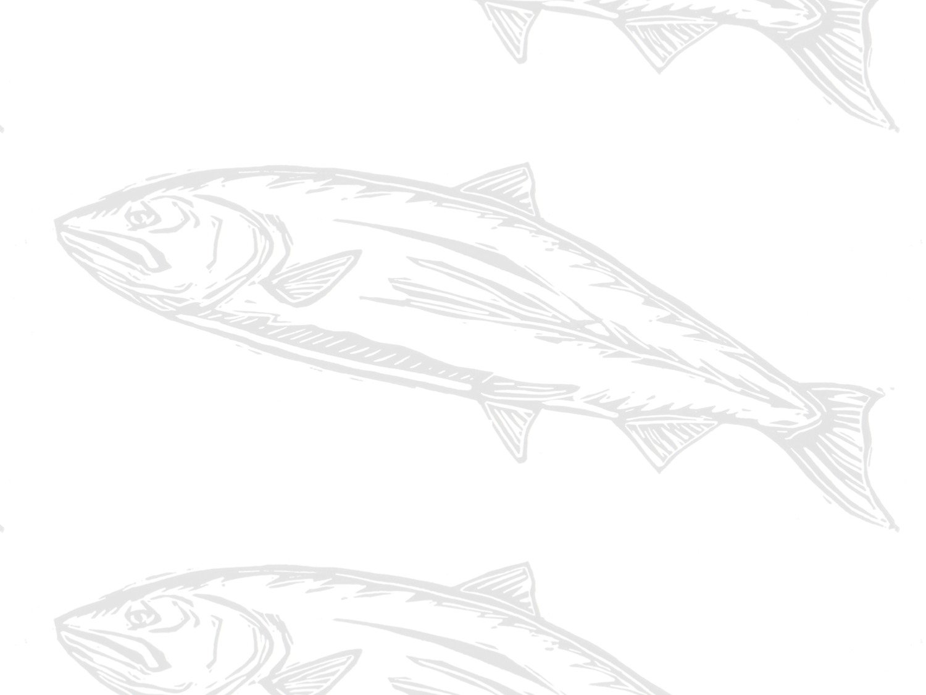

Contents

**1.** **Background and purpose** 3

**2.** **Overview of process (steps)** 4

**3.** **Required programs and data files** 4

**4.** **Step 1: Select tag groups** 5

**5.** **Step 2: Query RMIS for release/recovery data** 5

**6.** **Step 3: Filter RMIS data for importing to CAS** 5

**7.** **Step 4: Load filtered CWT data into CAS** 5

**8.** **Step 5: Run FRAMBuilder** 6

**9.** **Step 6: Export data** 6

**10.** **Other FRAMBuilder functions/features** 6

**11.** **Limitations to FRAMBuilder and opportunities for enhancement** 6

**Appendix A. Notes and exceptions for specific stock processing** 6

**Appendix B. Overview of the FRAM-modified CAS database** 6

1. **Background and purpose**

General purpose

Although the Regional Mark Processing Center’s (RMPC) Regional Mark Information System (RMIS) contains considerable information about the recovery of Chinook salmon with coded-wire tags (CWT), considerable processing must occur in order to translate this information into currency that’s meaningful within a FRAM base period calibration context. Firstly, individual tag groups must be associated with a specific FRAM model stock. Secondly, tags recovered at a particular location (indicated by RMIS location code), time, and using a particular gear, must be mapped to one of FRAM’s model fisheries and time steps. The FRAMBuilder program and workflow described here was developed to fulfill these needs, among others. For instance, the program, and companion FRAM-CAS database, was modified to facilitate the preparation of inputs for estimating the parameters of the von Bertalanffy growth functions used by FRAM.

The connection to CTC tools

Early in the development of FRAMBuilder and the overall CWT mapping workflow, the base period workgroup (BPW) identified distinct advantages/benefits to leveraging the Pacific Salmon Commission’s Chinook Technical Committee’s (CTC) CWT analysis tools (i.e., the Cohort Analysis System [CAS] mapping program and companion database) within a FRAM calibration context. The BPW ultimately decided to tie FRAMBuilder to the CTC world because this connection: (1) allows for the seamless integration of CTC ‘Auxiliary’ CWT files, agency-supplied/prepared files that supplement or correct known errors/gaps in RMIS’s CWT recovery information; (2) facilitates the efficient inclusion of screened/vetted CWT release groups (i.e., selected by CTC members with regional expertise) into the calibration database; and (3) increases the overlap in information driving models supporting the management decisions of the PSC, the Pacific Fishery Management Council (PFMC), and state–tribal co-managers. Additionally, given some overlap in the fishery assessment units used by the CTC and in FRAM, the integration of CAS into the FRAM calibration workflow offered efficiency in the form of an initial stage of RMIS-to-FRAM mapping.

Document scope

This user’s manual is meant to serve two purposes. Firstly, it provides a roadmap of the process that gets one from raw RMIS CWT release/recovery data to something useable in a FRAM calibration. Secondly, it provides basic documentation on the structure/function of the FRAMBuilder program, its companion FRAM-CAS database, and the ruleset it follows to get CWT recoveries from the initial CAS stage of mapping to a final FRAM fishery/time step state. As for the tools ‘borrowed’ from the CTC (i.e., CAS.exe), we provide only a brief sketch here and refer the reader to CTC resources for further documentation.

1. **Overview of the process**

In concept, the procedures to map an individual CWT recovery to a FRAM stock and fishery are straightforward: (a) in screening candidate codes, make a determination regarding which tags are suitable representatives for model stocks, and (2) given recovery details, such as RMIS location codes, gear codes, dates, etc., make a determination regarding the model fishery/time step to which the recovery belongs. In practice, however, this task is extremely difficult given that thousands of tag codes (= unique release groups) are available for consideration, resulting in hundreds of thousands of individual tag recoveries that must be mapped from one of tens of thousands of unique location-gear code combinations to one of FRAM’s seventy-two model fisheries. The FRAMBuilder workflow, although cumbersome at first glance, boils this seemingly insurmountable challenge down to a task that can be achieved by one person in a relatively short amount of time (i.e., assuming that candidate codes have been selected and auxiliary files have been acquired). It commences according to the following steps (Figure 1), each of which will be described in gory detail further below:

1. Select tag groups.
2. Query RMIS for release/recovery data.
3. Load RMIS query results into the CTC Filter database, and query it for CAS inputs.
4. Load tags into CAS (i.e., stage 1 of mapping – to CTC fishery strata).
5. Run FRAMBuilder (i.e., map/process recoveries).
6. Export data for calibration input files.

In addition to these steps, a handful of other functions can be invoked during step 5, depending on a user’s needs. These are also described further below. The remainder of this document is organized around each of these steps, where each subsection offers both ‘how to’ details and documentation on processing decisions, algorithms, etc. where necessary.

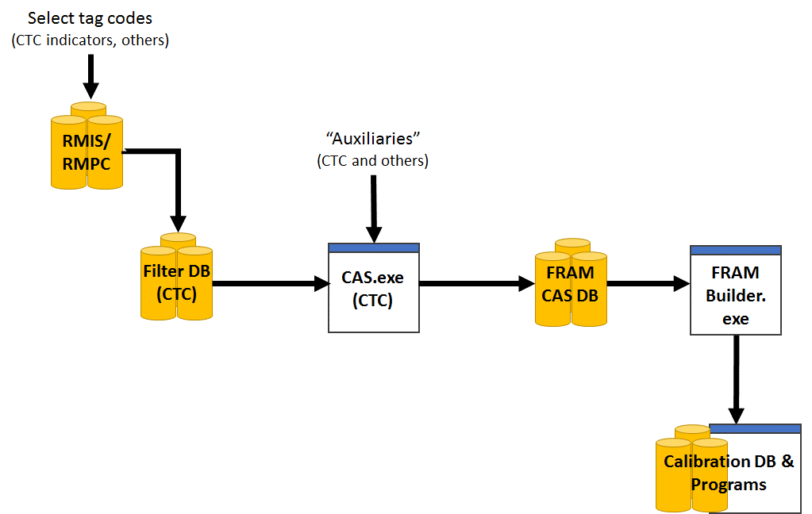

**Figure 2.1.** Relationships between the databases and programs used to construct FRAM base period calibration input files.

1. **Required programs and data files**

**Data Files**

* **A list of tag codes:** A list of tag codes is needed for the purposes of querying RMIS (release/recovery), as well as for populating the CTC Filter database’s ‘STKCDS’ table.
* **CWT release data**: These are the raw release details for the chosen codes, acquired from RMIS via a ‘Tagged Releases’ query; query results are downloaded as a CSV, with the headings specified under Step 2 below.
* **CWT recovery data**: These are the raw recovery details for the selected codes, acquired from RMIS via a ‘Recoveries By Tag Code’ query; query results are downloaded as a CSV, with the headings specified under Step 2 below.
* **Auxiliary files (or ‘auxiliaries’):** These are text files (*.csv or *.txt), prepared by CTC members from a variety of agencies/jurisdictions, that contain supplementary CWT recovery information that is meant to augment (or revise) the CWT information acquired from RMIS for some stocks; these files are typically created on a stock/code basis and are necessary to ensure the calibration process includes the most accurate information. For example, CWT recoveries in escapement—a major anchor point for the type of backwards cohort reconstruction underlying FRAM calibration—are not available via RMIS for many Canadian stocks.

**Databases (all Microsoft Access)**

* **The CTC’s Filter Database:** This is a Microsoft Access database into which the RMIS release/recovery query results (above), combined with a tag list (‘STKCDS’) are loaded. Using two custom queries, this database returns RELEASES.txt and RECOVERIES.txt files which can be imported directly to the FRAM-CAS database.
* **A FRAM-modified CAS database (FRAM-CAS hereafter)**: This Access database is an adaptation of the CTC CAS database (final preseason 2013 version[1]), which includes several tables (and added fields to existing tables) designed to (1) cross-walk CTC fishery strata to FRAM fisheries or (2) to house/contain mapped outputs for direct export/use in CAS.

**Programs**

* **FRAMBuilder 2.0:** Because FRAMBuilder is very much an interactive program subject to ad hoc changes/revisions to fulfill the BP team’s evolving needs, it hasn’t yet been developed into a distributed, fully compiled .exe file (i.e., ‘production mode’). Thus, the ‘program’ is actually a Microsoft Visual Studio solution (.sln) file that is operated within the development environment (i.e., Visual Studio, version 2008+).
* **The CTC’s CAS (and dll)**: CAS1.5_No_Restrictions.exe and CASLib.dll (2013 versions)
* **Visual Studio, version 2008+**: To operate FRAMBuilder ‘in the environment’ you will need a compiler; Visual Studio Express for desktops is a good free option (if Professional isn’t on your list of programs).
* **Others**:Although they aren’t tied explicitly to the mapping procedures outlined here, there are both R and OpenBUGS programs that estimate parameters for growth functions from CWT length observations (i.e., mapped to FRAM fishery and size limit regulation) summarized by FRAMBuilder.

1. **Step 1: Select tag groups**

Although the rationale surrounding the final decisions to include/exclude tag codes is beyond the scope of this document, here we outline the basic guidelines used to select the codes contained in the current calibration dataset. Firstly, we preferentially selected CWT codes associated with CTC ER indicator stocks given that CTC members with regional expertise have already screened what’s available to best represent natural and hatchery Chinook stocks within their jurisdiction. For stocks/regions beyond the CTC’s scope, selection was guided by the following criteria/considerations:

* Selection was limited to brood years 2005-2008; additional brood years were included for special calibration analyses (e.g., out-of-base procedures relied on brood years 2002-2004).
* Only stocks belonging to the ‘5000’ series of marks (i.e., adipose-fin clipped) were included; unmarked fish could not be used due to (1) their absence from CWT catch in visual-only sampled fisheries and (2) absence from mark-selective fishery catches.
* We generally avoided CWT release groups (1) from ‘experimental’ production groups (e.g., novel stock crosses), (2) with questionable warning flags, (3) that were released at stages earlier than the fingerling stage, and/or (4) that were released in locations with difficult/poor escapement enumeration (e.g., acclimation ponds) were generally avoided.

For further detail on codes selected for particular stocks, please refer to the Chinook FRAM stock profile spreadsheet, available for download at: <https://github.com/petemchugh/FRAMBuilder/blob/master/2016ChinFRAMBP_StockProfiles012816_Protected.xlsx>.

1. **Step 2: Query RMIS for release/recovery data**

Given a set of codes, the next task is to query RMIS for the necessary release and recovery information. The online system is at <http://www.rmis.org/rmis_login.php?action=Login&system=cwt>, and requires that you have a user account. Release data are acquired via the ‘Releases: Tagged Releases’ query form, which requires your tag list. After entering the list of tags (Figure 5.1) and clicking ‘Retrieve’, you’ll have to choose the type of report (CSV in email or browser is preferred; Figure 5.2), and then specify what fields you’d like to see in the query results. For the purposes of loading the Filter Database, there’s a specific User List that you’ll need to use (Note: you can copy/paste the list from here):

tag_code_or_release_id

species

run

brood_year

release_location_code

first_release_date

last_release_date

cwt_1st_mark

cwt_1st_mark_count

cwt_2nd_mark

cwt_2nd_mark_count

non_cwt_1st_mark

non_cwt_1st_mark_count

non_cwt_2nd_mark

non_cwt_2nd_mark_count

hatchery_location_code

stock_location_name

related_group_type

related_group_id

Upon validating the user list and clicking the ‘Run’ button, results will be returned to your screen/email; these, less the junk header (browser report only) text that reads ‘You are here: Home > RMIS Standard Reporting > Query Results > Report CSV’ can be copied/pasted into a text editor and saved for importing to the Filter Database.

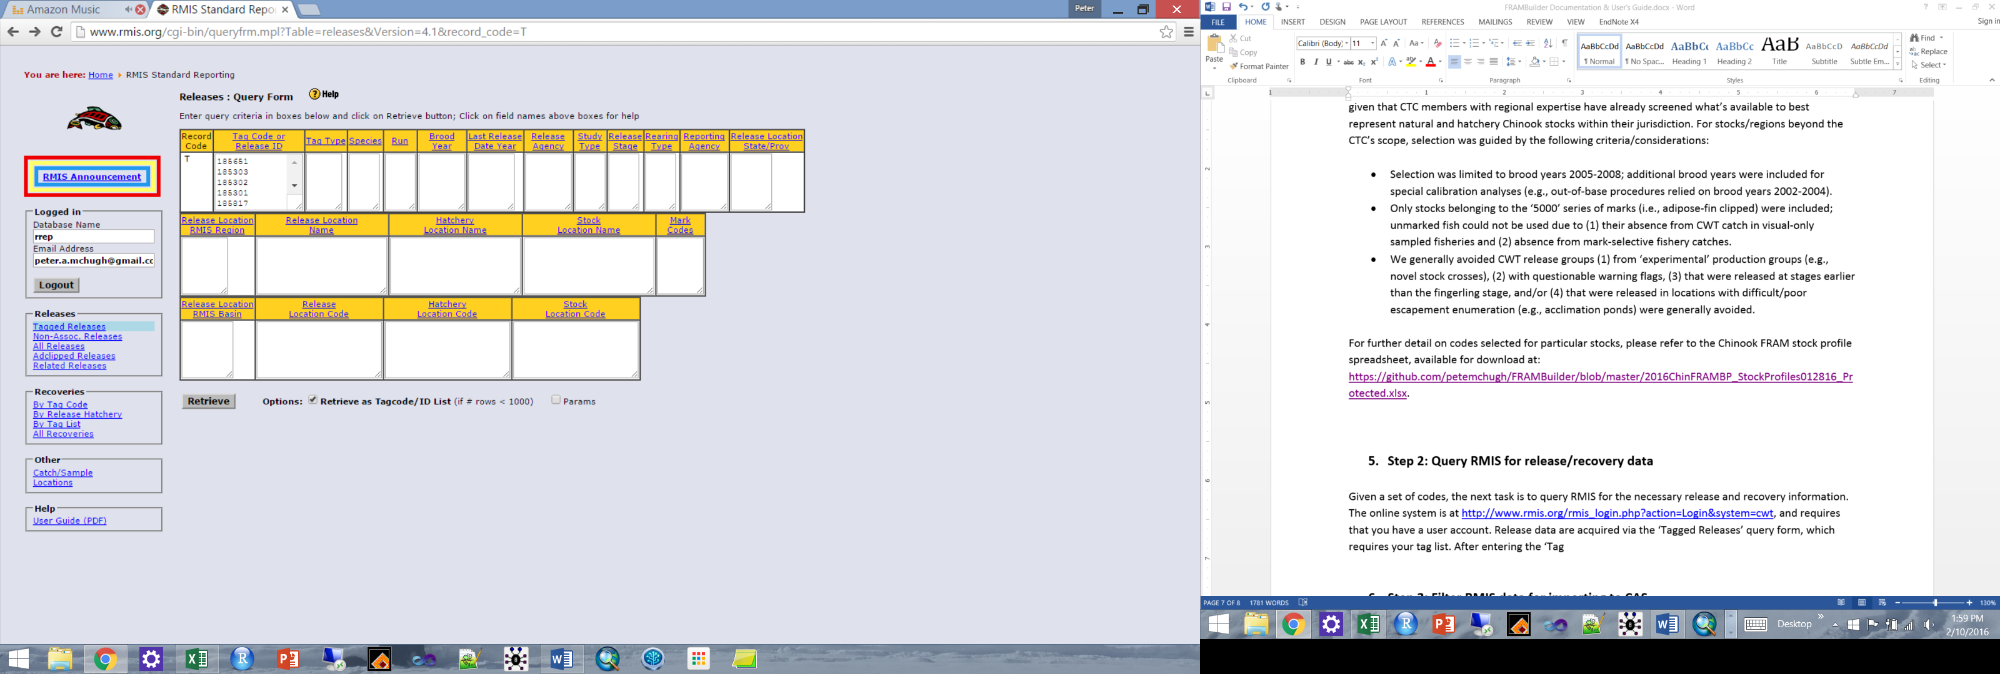

**Figure 5.1.** RMIS’s ‘Tagged Releases’ query form, wherein the set of codes desired is specified.

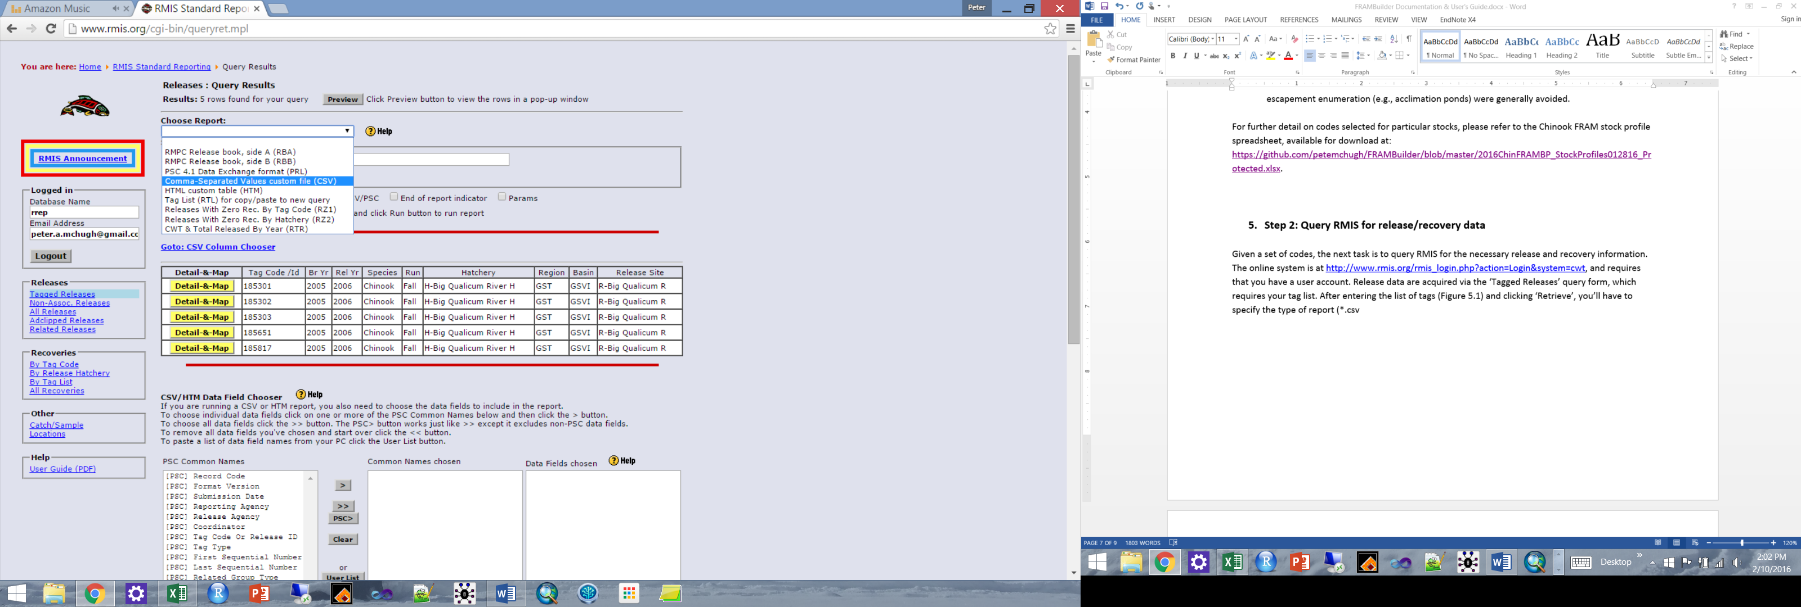

**Figure 5.2.** Form for specifying query result specs, specifically report type (CSV).

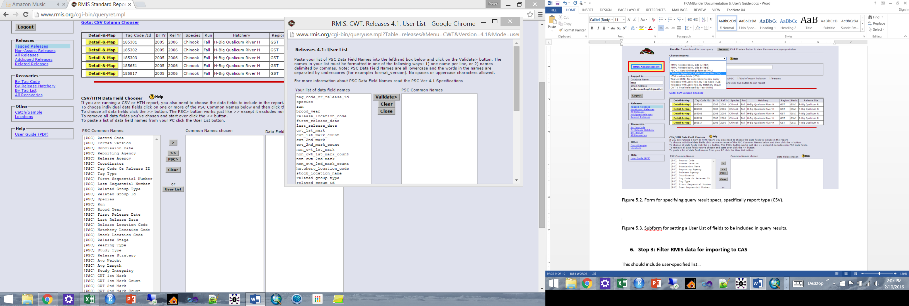

**Figure 5.3.** Sub-form for setting a User List of fields to be included in query results.

The steps followed for running the custom ‘Releases: Tagged Releases’ query are now repeated for the ‘Recoveries: By Tag Code’ query, only this time, the custom User List will include the following fields (NOTE: unlike releases, only 180 codes can entered here):

recovery_id

recovery_date

period_type

period

species

sex

length

length_code

tag_code

tag_status

estimation_level

recovery_location_code

fishery

estimated_number

sample_type

run_year

recorded_mark

catch_sample_id

detection_method

sampled_maturity

reporting_agency

adclip_selective_fishery

Query results can now be saved as a CSV imported into the Filter Database. Because it will take multiple queries to get release information for the 700+ CWT codes included in the FRAM calibration dataset, be sure to save these with clearly defined names or append them to a single, growing CSV (be sure to remove column headings if you append output). Also, be careful when opening/viewing these query results before importing into Filter Database; CSVs open readily in Excel and can be unintentionally reformatted upon opening (e.g., text to numeric will drop leading zeros on some codes).

1. **Step 3: Filter RMIS data for importing to CAS**

The release and recovery CSV files constructed in Step 2 can now be imported directly into the Filter Database. This is achieved via the Microsoft Access functions under External Data > Import & Link > Text File. This allows you to specify the appropriate Releases.CSV or Recoveries.CSV file in the ‘File Name field’ (browse and point to accordingly) and append records to the appropriate database table (RELEASES or RECOVERIES). To minimize potential error, it is generally advisable to start with a clean Filter Database for these steps.

After loading RMIS query results, the Filter Database’s ‘STKCDS’ table (Figure 6.1) must be populated with the tag codes contained in the release and recovery datasets. The three letter abbreviations in the STOCK field must follow existing conventions (i.e., be in the CAS ‘SpeciesStock’ table), otherwise records will be rejected [Note: although all FRAM stocks are already covered, new stocks can be added via steps contained in CTC CAS help files].

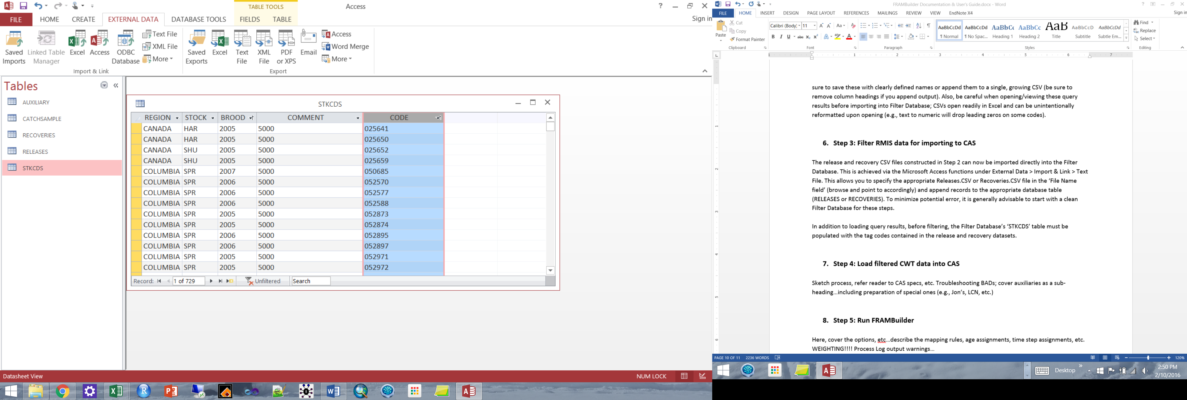

**Figure 6.1.** The Filter Database’s ‘STKCDS’ table, which requires jurisdiction, stock acronym, brood, marking, and CWT code information.

After the Filter Database is loaded with necessary content, these data are ‘filtered’ via two queries (releases, recoveries) that are saved as .txt files for importin to CAS via. The ‘ERARECOVERIES’ filter query eliminates (1) recovery observations that cannot be used in a quantitative analysis (i.e., RMPC ‘sample type’ = 5), (2) high seas fishery recoveries, and (3) some recoveries that are dealt with as auxiliaries (e.g., Canadian escapements); see **Appendix A** for SQL query details. The ‘ERARELEASES’ filter query, in contrast to recoveries, does minimal joining (STKCDS to Releases) and reformats the release data in prep for CAS import. Step 3 should yield two text files, ERARELEASES.TXT and ERARECOVERIES.TXT (you save under different names as you see fit).

1. **Step 4: Load filtered CWT data into CAS**

Using the CAS1.5_No_Restrictions.exe program (CAS program or CAS.EXE hereafter), the ERARELEASE.TXT and ERARECOVERIES.TXT files will can now be imported into the FRAM-CAS database. Depending on the application, you may want to first clear out the entire FRAM-CAS database, using the CAS program (Figure 7.1). First, however, you must connect your CAS program to the FRAM-CAS database with which you’re working (you will be prompted to do so upon opening the program). Once connected, you can clear things out as needed (Figure 7.1) and then you’re ready to import filtere database output releases (Figure 7.2), recoveries, and/or any auxiliary files (discussed further below). The procedure for each file type is the same, you first point the program to the appropriate release, recoveries, or auxiliary text file (.TXT or .CSV) and menu, then you click ‘Load’ and wait for the process to complete. Once CAS has finished loading the data, you should examine the running CAS error log (‘CASErrors.TXT’, this is written where the program occurs) and the ‘*.BAD’ (a text file) associated with each input you’ve attempted to load—these will tell you which (if any) records were rejected and offer you clues regarding why this occurred.

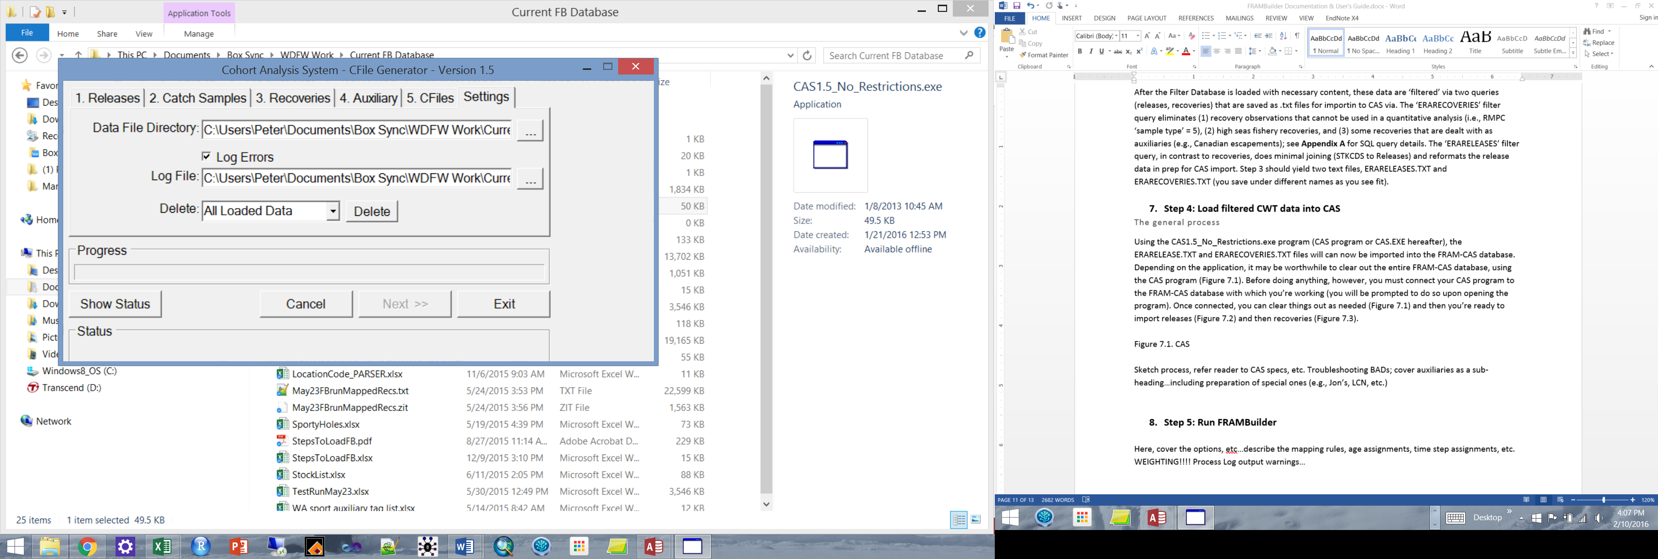

**Figure 7.1.** The CAS program’s Settings menu, the location in which loaded data can be deleted.

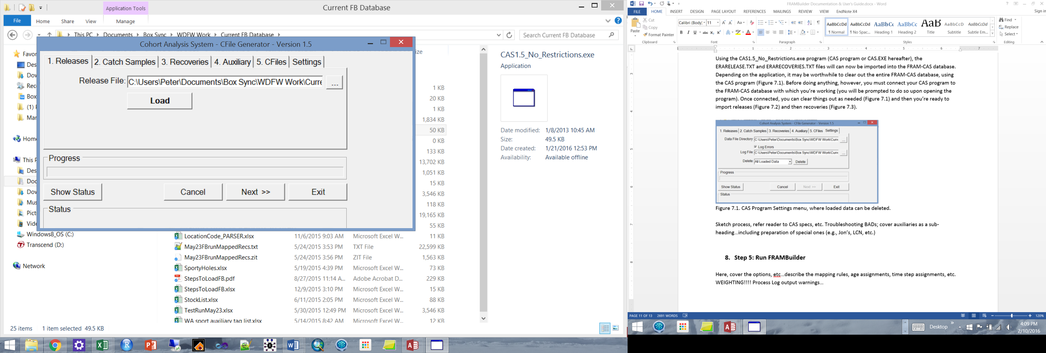

**Figure 7.2.** The CAS program’s Releases loading menu.

Troubleshooting rejected releases and recoveries

Typically a handful, but sometimes many, records will be rejected during the FRAM-CAS database loading process. This can feel like the most cumbersome step of the FRAM-CAS database loading process, but with some patience and insight is relatively easy to work through. The problems and solutions include (*solution in italics*):

1. For releases, this can arise because the stock code isn’t included in the ‘SpeciesStock’ database table (this shouldn’t happen, but if it does, see CTC help file guidance); *upon adding the new stock’s details, it should load correctly*.
2. For recoveries, the recovery location may not be parsing in such a way that can get a recovery from an RMIS location code all the way to a CTC fine-scale fishery; *in this case, you’ll have to manually add a parsed location (with fine-scale fishery mapping) to the FRAM-CAS database ‘FisheryLookup’ table*, *and reload the associated BAD records*; e.g.: RMIS Location Code: “3F10510 080122 R” parses to the fields in green, and you must supply the red info (Fishery = CTC Fishery Stratum, CWDBFishery = RMIS Gear Code, Species = 1 for Chinook; gray fields can be left empty):

|  |  |  |  |  |  |  |  |  |  |  |  |  |  |  |  |  |  |  |
| --- | --- | --- | --- | --- | --- | --- | --- | --- | --- | --- | --- | --- | --- | --- | --- | --- | --- | --- |
| Id | Fishery | CWDBFishery | StateProvince | WaterType | Species | Stock | Sector | Region | Area | Location | SubLocation | StartMonth | StartDay | EndMonth | EndDay | F17 | F18 | F19 |
|  | 1079 | 54 | 3 | F | 1 |  | 1 | 05 | 10 | 080122 | R |  |  |  |  |  |  |  |

The parsing rules from RMIS Location Code to field values are: Char(1) = StateProvince; Char(2) = WaterType; Char(3) = Sector; Char(4-6) = Region; Char(7-9) = Area; Char(10-16) = Location; Char(17-19) = Sub-Location.

1. In other cases, the recovery location might be parsing correctly, but a fishery really isn’t part of the FRAM (or CTC universe). In rare cases, for example, Chinook FRAM’s stocks have been recovered in net fisheries in Cook Inlet and Prince William Sound. *These rarities are not included* *and treated as though they’re ‘natural mortality’*.
2. On rare occasions, RMIS contains records with a valid sample type, but no ‘estimated number’ for a particular tag recovery. *In these cases, the user must decide what to do, i.e., to enter a value or omit altogether.* For example, if it’s likely a data error and in fact each fish represents an individual (e.g., censused escapement at a hatchery), then these records could be given an estimated number of 1.0 and reloaded. It is on the BP team, however, to make the call given whatever information is available (regional expertise/contacts, etc.).
3. A portion of the auxiliary data you’re supplying isn’t part of the tag set of interest. For example, a CTC member from Canada may supply escapements for all of their stocks for all years in a single file, whereas you’re only interested in 2005-2008 broods. *If this is the basis for rejection, there’s nothing more that you need to do*.

The good news is that, generally speaking, once a solution to a parsing problem or release rejection problem is resolved in the FRAM-CAS database, it will address all future instances subject to the same circumstances (and/or future reloads).

What are auxiliaries?

As noted above, so-called auxiliary CWT recovery files are also loaded into the FRAM-CAS database during this stage of the overall process, and are denoted as such in the ‘CWDBRecovery’ table (‘Auxiliary’ = T/F field). These files, which are supplied by regional experts who steward CWT recovery data for particular stocks or fisheries, are meant to either augment or correct the data acquired via RMIS for the tag groups in question. While the deficiencies/errors in RMIS content and/or the basis for auxiliary file creation are beyond the scope of this manual, these files are needed to ensure that all observations of tagged model stock cohorts are correctly captured in the FRAM BP dataset. Because these datasets are routinely updated, it is important to acquire the latest[2] versions from the appropriate CTC point(s) of contact prior to completing a full FRAM-CAS loading process. Finally, similar input files may need to be created for any non-CTC stocks necessitating similar supplementary or revisionary data (e.g., for unsampled freshwater sport fisheries in Willapa Bay).

For further documentation on the CAS program and database, see the design specs document prepared by Wostman and Associates, Inc. for ADFG and the CTC (https://github.com/petemchugh/FRAMBuilder/blob/master/CTC%20CAS%20Documentation/CAS%20Design%20Spec.doc).

1. **Step 5: Run FRAMBuilder**

Here, cover the options, etc…describe the mapping rules, age assignments, time step assignments, etc. WEIGHTING!!!! Process Log output warnings…

1. **Step 6: Export data**

Sketch process, refer reader to CAS specs, etc. Troubleshooting

1. **Other FRAMBuilder functions/features**

Preparing data for analyzing growth…

1. **Limitations to FRAMBuilder and opportunities for enhancement**

Sketch process, refer reader to CAS specs, etc. Troubleshooting

**Appendix A. CTC Filter Database Recoveries Query Details/notes**

SELECT RECOVERIES.recovery_id, RECOVERIES.recovery_date, RECOVERIES.period_type, RECOVERIES.period, RECOVERIES.species, RECOVERIES.sex, RECOVERIES.length, RECOVERIES.length_code, RECOVERIES.tag_code, RECOVERIES.tag_status, RECOVERIES.estimation_level, RECOVERIES.recovery_location_code, RECOVERIES.fishery, RECOVERIES.estimated_number, RECOVERIES.sample_type, RECOVERIES.run_year, RECOVERIES.recorded_mark, RECOVERIES.catch_sample_id, RECOVERIES.detection_method, RECOVERIES.reporting_agency

FROM RECOVERIES INNER JOIN STKCDS ON RECOVERIES.tag_code = STKCDS.CODE

### note, across all subsets, sample_type <> 5 excludes voluntary recoveries with no awareness

WHERE ((((RECOVERIES.fishery)<"60") AND ((RECOVERIES.sample_type)<>"5") AND ((STKCDS.REGION) In ("WASH","COLUMBIA","OREGON")))

## no high seas included for WA/ColR/OR ##

OR

(((RECOVERIES.fishery)<"50") AND ((RECOVERIES.sample_type)<>"5") AND ((RECOVERIES.reporting_agency)="CDFO") AND ((STKCDS.REGION)="CANADA"))

## no Canadian escapements (they’re entered as auxiliary) ##

OR

(((RECOVERIES.fishery)<"49" Or (RECOVERIES.fishery)="94") AND ((RECOVERIES.sample_type)<>"5") AND ((RECOVERIES.reporting_agency) In ("ADFG","NMFS")) AND ((STKCDS.REGION)="ALASKA"))

## For AK, include standard fisheries and marine trap (net) ##

OR

(((RECOVERIES.fishery)<"60") AND ((RECOVERIES.sample_type)<>"5") AND ((RECOVERIES.reporting_agency)<>"CDFO") AND ((STKCDS.REGION)="CANADA"))

OR

(((RECOVERIES.fishery)<"70" Or (RECOVERIES.fishery)="94") AND ((RECOVERIES.sample_type)<>"5") AND ((RECOVERIES.reporting_agency) Not In ("ADFG","NMFS")) AND ((STKCDS.REGION)="ALASKA"))

OR

(((RECOVERIES.fishery)>="60" And (RECOVERIES.fishery)<"70") AND ((RECOVERIES.sample_type)<>"5") AND ((RECOVERIES.reporting_agency) Not In ("ADFG","NMFS","CDFO")) AND ((STKCDS.REGION)="CANADA"))

OR

(((RECOVERIES.fishery)>="60" And (RECOVERIES.fishery)<"70") AND ((RECOVERIES.sample_type)<>"5") AND ((RECOVERIES.reporting_agency) Not In ("ADFG","NMFS","CDFO")) AND ((STKCDS.REGION) In ("WASH","COLUMBIA","OREGON")))) and Left(RECOVERIES.recovery_location_code,5) <> "1M1DF";

**Appendix B. Notes and exceptions for specific stock processing**

e.g., ageing up by one year Willamette and CKL spring Chinook…origin is in the old FRAMBuilder program (Kurt Reidinger)

Create LCN auxiliaries as needed (i.e., over and above mapped FRAM-CAS CWT Recovery/Release content, there may be LRH or CWF auxiliary data too).

**Appendix C. Overview of the FRAM-modified CAS database**

Sketch process, refer reader to CAS specs, etc. Troubleshooting

1. The FRAM-CAS fishery crosswalk adheres strictly to the CTC’s ‘fine scale’ fishery strata from 2013; any attempt to create an updated FRAM-CAS database will require an updated FRAM to CTC crosswalk (database table ‘FRAM_Fishery’.
2. Because the CTC’s fine-scale fishery change routinely, it may be necessary to modify auxiliaries to revert to the 2013 convention before using; additionally.